walmart <- read.csv(file.choose(), stringsAsFactors = FALSE)

str(walmart)

library(lubridate)

walmart$Date <- dmy(walmart$Date)

str(walmart)

# 1. which store has max sales

library(dplyr)

walmart %>% group_by(Store) %>% summarise(total_sales=sum(Weekly_Sales)) %>% arrange(desc(total_sales))

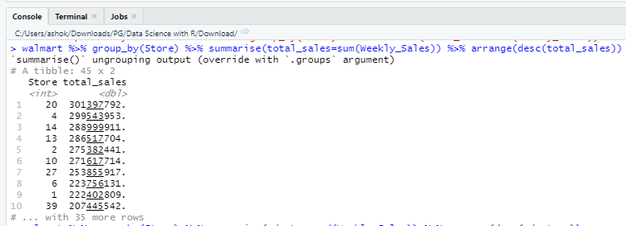

Result: Store 20

#2. max standard deviation

df <- walmart %>% group_by(Store) %>% summarise(sd_store=sd(Weekly_Sales), avg=mean(Weekly_Sales)) %>% arrange(desc(sd_store))

#coefficient of mean to sd = (sd/mean)*100

df$cv <- (df$sd_store/df$avg)*100

df

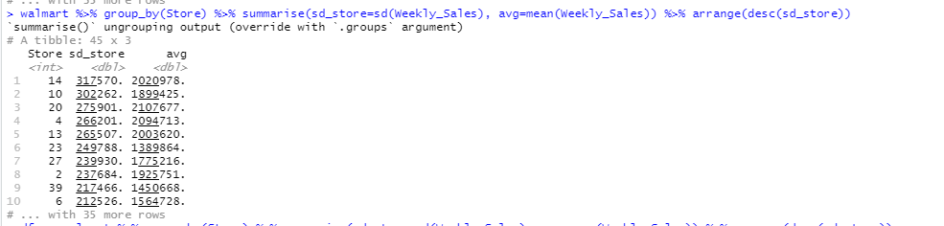

Result : Store 14

#3. which stores has good quarterly growth rate

walmart$qtr <- quarter(wallmart$Date, with_year = TRUE)

#aggregate by quarter

qtr_sales <- walmart %>% group_by(Store, qtr) %>% summarise(qtrly_sales=sum(Weekly_Sales))

View(qtr_sales)

qtr_sales$lag_4 <- lag(qtr_sales$qtrly_sales,4)

View(qtr_sales)

q3_2012 <- qtr_sales %>% filter(qtr==2012.3)

View(q3_2012)

q3_2012$gr <- 100*(q3_2012$qtrly_sales-q3_2012$lag_4)/(q3_2012$lag_4)

arrange(q3_2012, desc(gr))

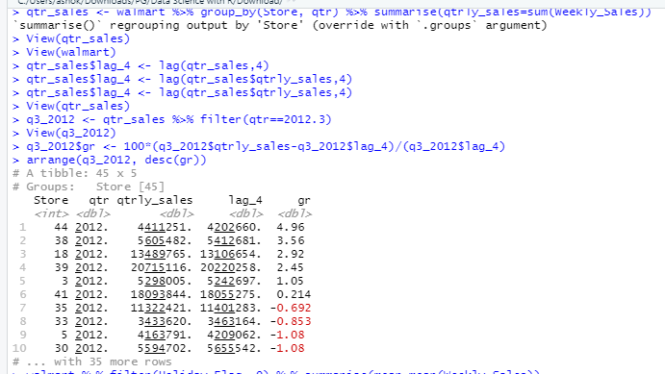

#4. impact of holidays

walmart %>% filter(Holiday_Flag==0) %>% summarise(mean=mean(Weekly_Sales))

#mean sales for all stores = 1041256

#holidays which have higher sales

#those weeks which have holidays

df_holiday <- walmart %>% filter(Holiday_Flag==1) %>% group_by(Date) %>% summarise(avg=mean(Weekly_Sales))

df_holiday %>% filter(avg>1041256)

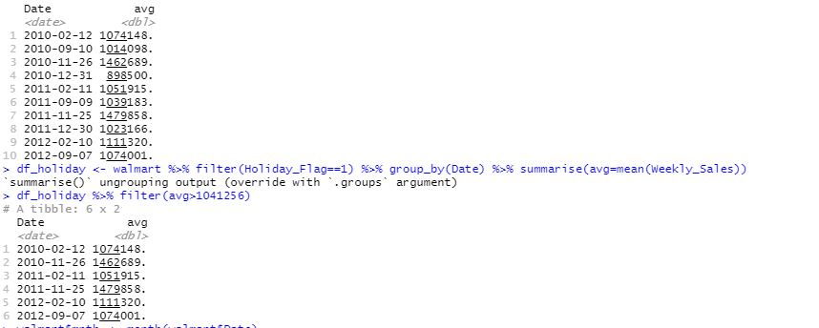

#5. provide monthly and semester view of sales

walmart$mnth <- month(walmart$Date)

walmart$yr <- year(walmart$Date)

walmart$sem <- semester(walmart$Date, with_year = TRUE)

#concatenate date and year

walmart <- walmart %>% mutate(mon_yr= paste(yr, mnth))

#provide monthly view

monyr <- walmart %>% group_by(mon_yr) %>% summarise(total_sales=sum(Weekly_Sales))

#bar plot to describe data

library(ggplot2)

ggplot(data = monyr, mapping = aes(mon_yr, total_sales)) +geom_bar(stat = 'identity')

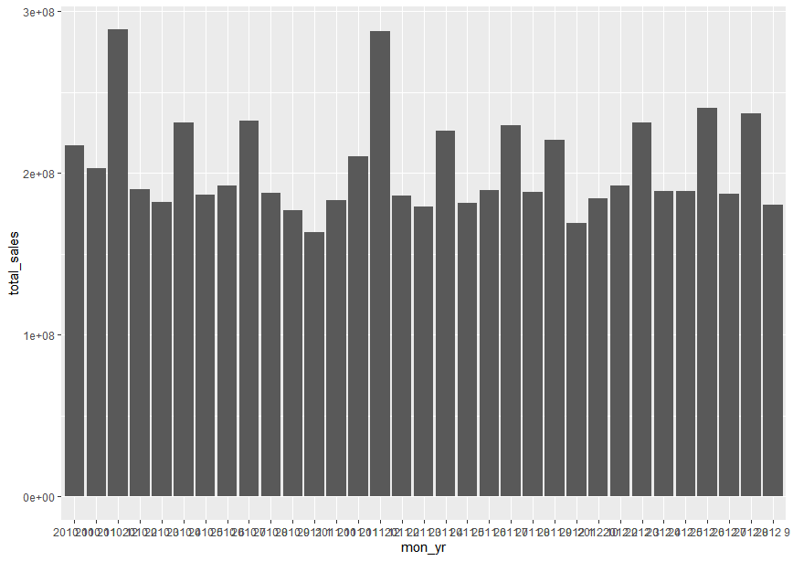

#semester aggregate

semyr <- walmart %>% group_by(sem) %>% summarise(total_sales=sum(Weekly_Sales))

#bar plot to describe data

ggplot(data = semyr, mapping = aes(factor(sem), total_sales)) +geom_bar(stat = 'identity')

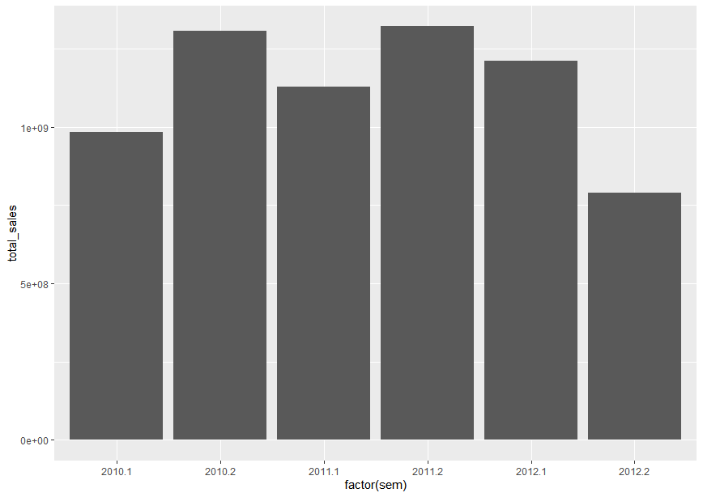

#statistical model

#for store 1

store_1 <- walmart %>% filter(Store==1)

store_1 <- store_1 %>% arrange(Date)

#restructure dates 1 for fst date

store_1$new_dt <- row_number(store_1$Store)

View(store_1)

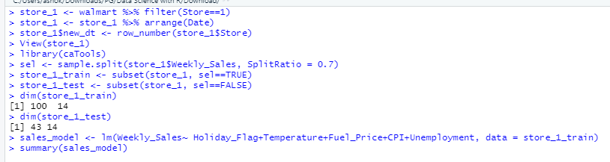

#hypothesis if CPI, unemployment, fuel price have any impact on sales

library(caTools)

sel <- sample.split(store_1$Weekly_Sales, SplitRatio = 0.7)

#training data set

store_1_train <- subset(store_1, sel==TRUE)

#test data

store_1_test <- subset(store_1, sel==FALSE)

dim(store_1_train)

dim(store_1_test)

#train model on training data

sales_model <- lm(Weekly_Sales~ Holiday_Flag+Temperature+Fuel_Price+CPI+Unemployment, data = store_1_train)

summary(sales_model)

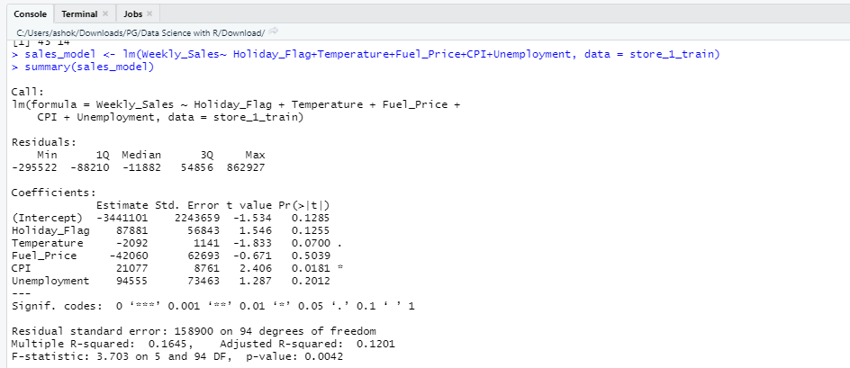

#F stats checks if all variables are simultaneously=0

#h0 : all coefficient for the model = 0

#since p <0.05 , so we reject the h0

#look at individual variables now

#H0: coefficient for each variable = 0

# holiday flag : p>alpha fail to reject, remove from model

# fuel_price, temp, unemployment : p>alpha fail to reject, remove from model

# CPI : p<alpha , reject h0, use in model.

sales_model <- lm(Weekly_Sales~ CPI, data = store_1_train)

summary(sales_model)

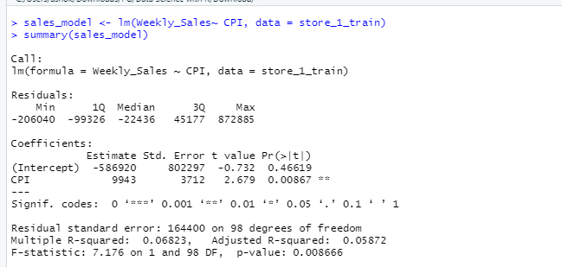

#change dates into days

day(store_1$Date)

store_1_train$day <- day(store_1_train$Date)

store_1_test$day <- day(store_1_test$Date)

sales_model <- lm(Weekly_Sales~ CPI+day, data = store_1_train)

summary(sales_model)

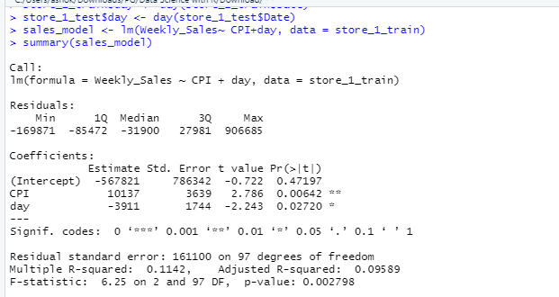

predict(sales_model,store_1_test)